***User Feedback Questionnaire – Visualizations in the Parkinson’s Project***

*Please fill out this questionnaire to help us evaluate the usability and clarity of our project's visualizations.*

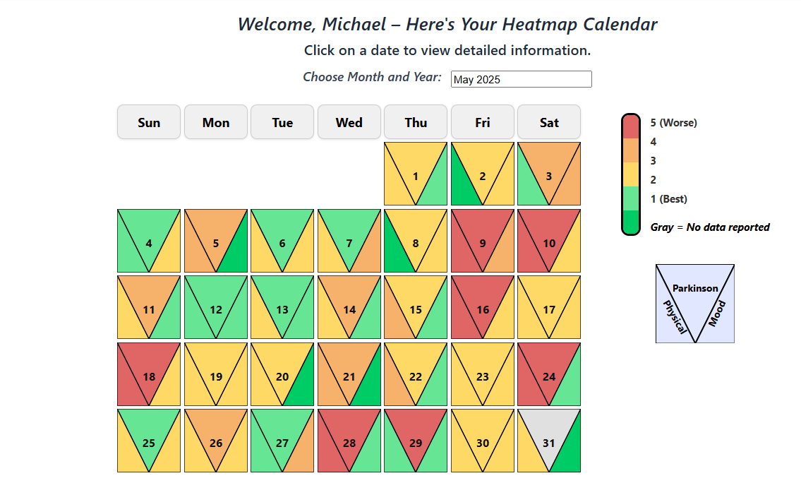***Heatmap Calendar Screen:***

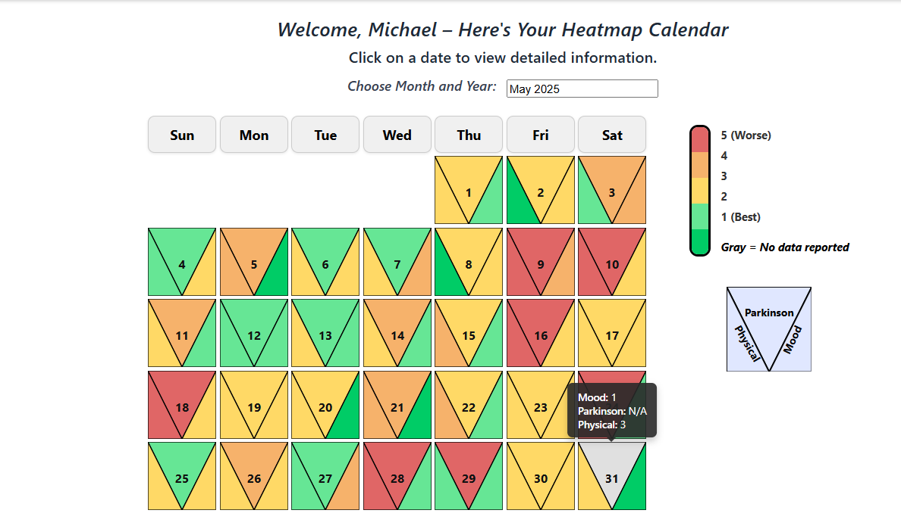**Screenshot of the user hovering over a day in the heatmap calendar:**

Please answer the following questions for the **Heatmap Calendar** visualization:

|  |  |  |  |  |  |  |  |
| --- | --- | --- | --- | --- | --- | --- | --- |
| Strongly agree |  |  |  |  |  | Strongly disagree |  |
| 7 | 6 | 5 | 4 | 3 | 2 | 1 |  |
|  |  |  |  |  |  |  | I thought the visualization was enjoyable |
|  |  |  |  |  |  |  | I found the visualization unnecessarily complex |
|  |  |  |  |  |  |  | I thought the visualization was easy to use |
|  |  |  |  |  |  |  | The use of visualization required considerable mental effort |
|  |  |  |  |  |  |  | The use of visualization was clear and understandable |
|  |  |  |  |  |  |  | The use of visualization was often frustrating |
|  |  |  |  |  |  |  | I thought the visualization was effective |
|  |  |  |  |  |  |  | I would imagine that most people would easily learn how to use this visualization. |

Please indicate what the advantages and/or disadvantages of **Heatmap Calendar** visualization are in your opinion?

Advantages: ____________________________________________________________________________________________________________________________________________________

Disadvantages: ____________________________________________________________________________________________________________________________________________________

**A dashboard screen that contains 4 graphs:**

1. Daily Analysis Graph.
2. Medication Intake Summary.
3. Protein Intake Summary.
4. Daily Activities Graph.

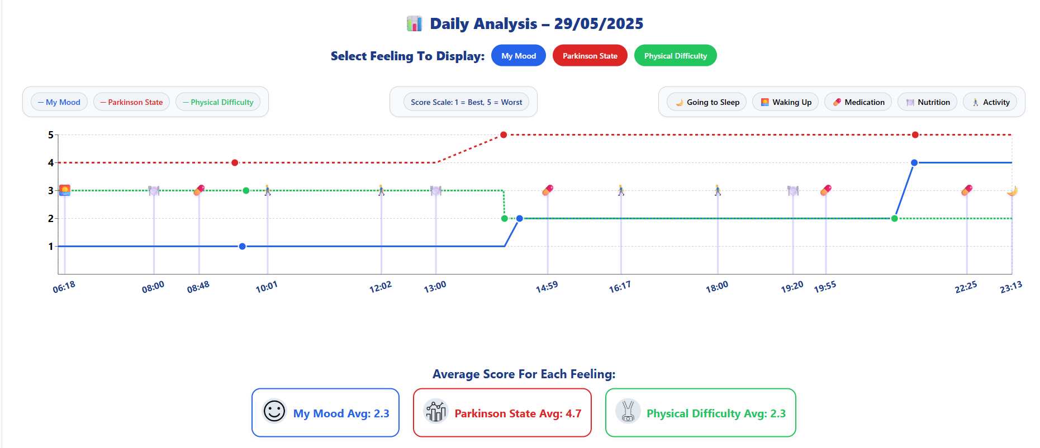***Daily Analysis Graph (Line chart):***

**Screenshot of the user hovering over an icon in the daily analysis graph:**

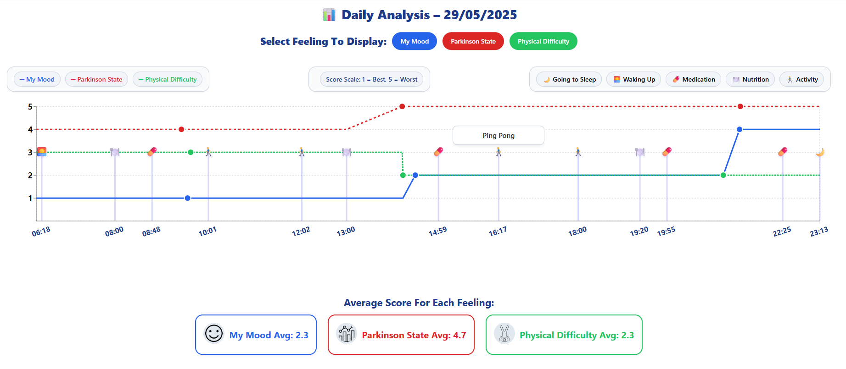

Please answer the following questions for the ***Daily Analysis Graph (Line chart)*** visualization:

|  |  |  |  |  |  |  |  |
| --- | --- | --- | --- | --- | --- | --- | --- |
| Strongly agree |  |  |  |  |  | Strongly disagree |  |
| 7 | 6 | 5 | 4 | 3 | 2 | 1 |  |
|  |  |  |  |  |  |  | I thought the visualization was enjoyable |
|  |  |  |  |  |  |  | I found the visualization unnecessarily complex |
|  |  |  |  |  |  |  | I thought the visualization was easy to use |
|  |  |  |  |  |  |  | The use of visualization required considerable mental effort |
|  |  |  |  |  |  |  | The use of visualization was clear and understandable |
|  |  |  |  |  |  |  | The use of visualization was often frustrating |
|  |  |  |  |  |  |  | I thought the visualization was effective |
|  |  |  |  |  |  |  | I would imagine that most people would easily learn how to use this visualization. |

Please indicate what the advantages and/or disadvantages of **Daily Analysis Graph** (Line chart) visualization are in your opinion?

Advantages: ____________________________________________________________________________________________________________________________________________________

Disadvantages: ____________________________________________________________________________________________________________________________________________________

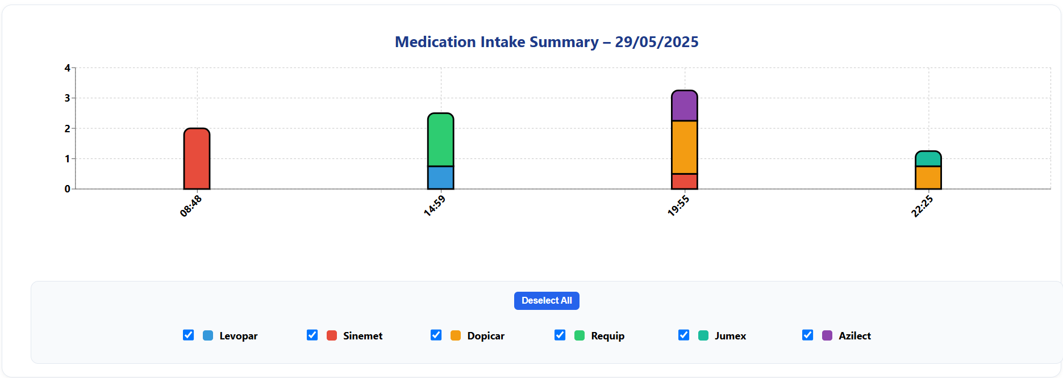**Medication Intake Summary:**

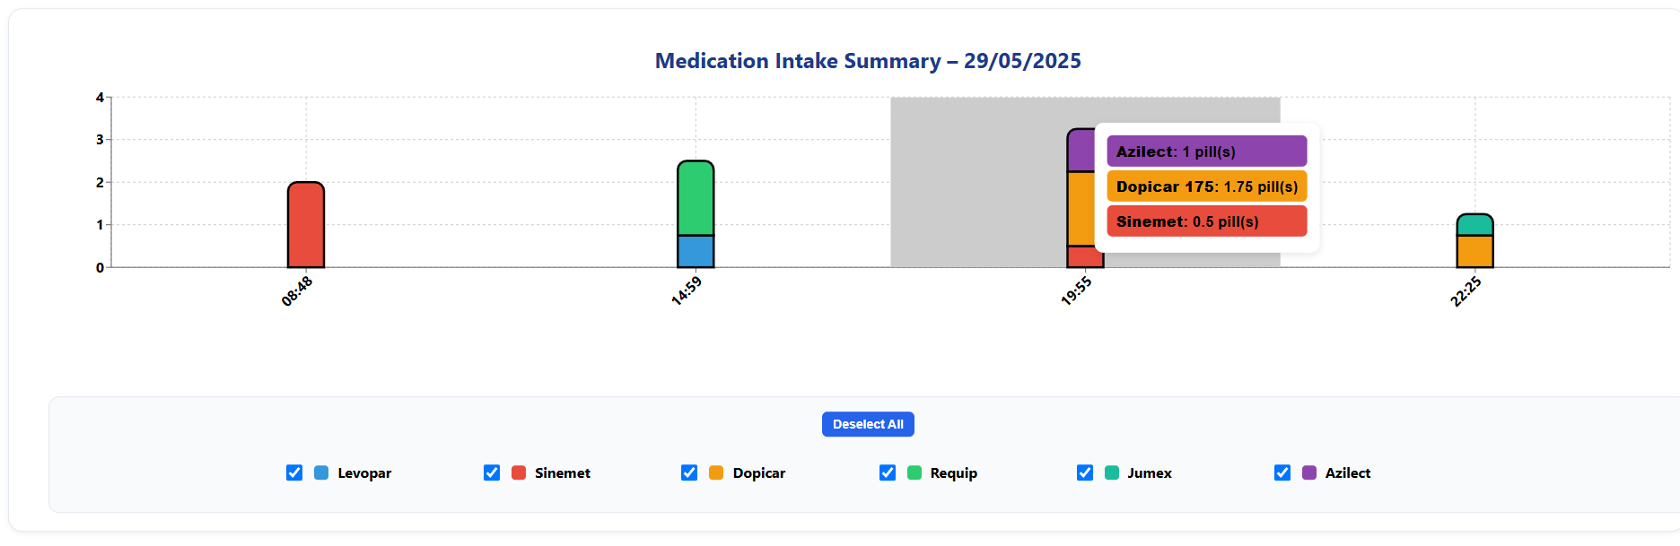**Screenshot showing a tooltip triggered by hovering over a medication bar:**

Please answer the following questions for the **Medication Intake Summary (Stack-Bar Chart)** visualization:

|  |  |  |  |  |  |  |  |
| --- | --- | --- | --- | --- | --- | --- | --- |
| Strongly agree |  |  |  |  |  | Strongly disagree |  |
| 7 | 6 | 5 | 4 | 3 | 2 | 1 |  |
|  |  |  |  |  |  |  | I thought the visualization was enjoyable |
|  |  |  |  |  |  |  | I found the visualization unnecessarily complex |
|  |  |  |  |  |  |  | I thought the visualization was easy to use |
|  |  |  |  |  |  |  | The use of visualization required considerable mental effort |
|  |  |  |  |  |  |  | The use of visualization was clear and understandable |
|  |  |  |  |  |  |  | The use of visualization was often frustrating |
|  |  |  |  |  |  |  | I thought the visualization was effective |
|  |  |  |  |  |  |  | I would imagine that most people would easily learn how to use this visualization. |

Please indicate what the advantages and/or disadvantages of **Medication Intake Summary (Stack-Bar Chart)** visualization are in your opinion?

Advantages: ____________________________________________________________________________________________________________________________________________________

Disadvantages: ____________________________________________________________________________________________________________________________________________________

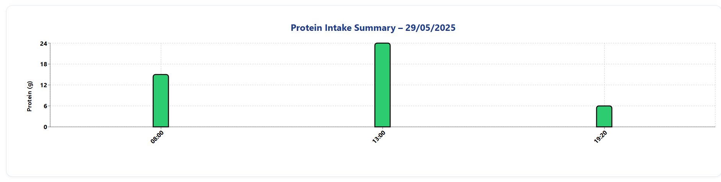**Protein intake summary:**

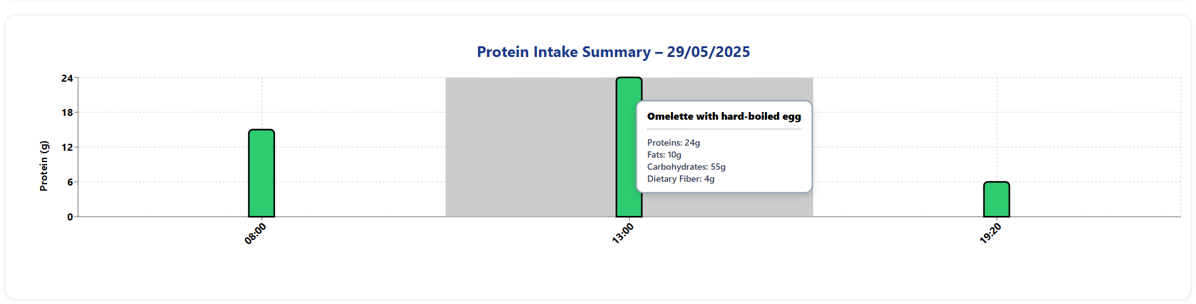**Screenshot of the user hovering over a nutrition bar to view detailed meal information:**

Please answer the following questions for the **Protein intake summary (Bar Chart)** visualization:

|  |  |  |  |  |  |  |  |
| --- | --- | --- | --- | --- | --- | --- | --- |
| Strongly agree |  |  |  |  |  | Strongly disagree |  |
| 7 | 6 | 5 | 4 | 3 | 2 | 1 |  |
|  |  |  |  |  |  |  | I thought the visualization was enjoyable |
|  |  |  |  |  |  |  | I found the visualization unnecessarily complex |
|  |  |  |  |  |  |  | I thought the visualization was easy to use |
|  |  |  |  |  |  |  | The use of visualization required considerable mental effort |
|  |  |  |  |  |  |  | The use of visualization was clear and understandable |
|  |  |  |  |  |  |  | The use of visualization was often frustrating |
|  |  |  |  |  |  |  | I thought the visualization was effective |
|  |  |  |  |  |  |  | I would imagine that most people would easily learn how to use this visualization. |

Please indicate what the advantages and/or disadvantages of the **Protein Intake summary (Bar Chart)** visualization are in your opinion?

Advantages: ____________________________________________________________________________________________________________________________________________________

Disadvantages: ____________________________________________________________________________________________________________________________________________________

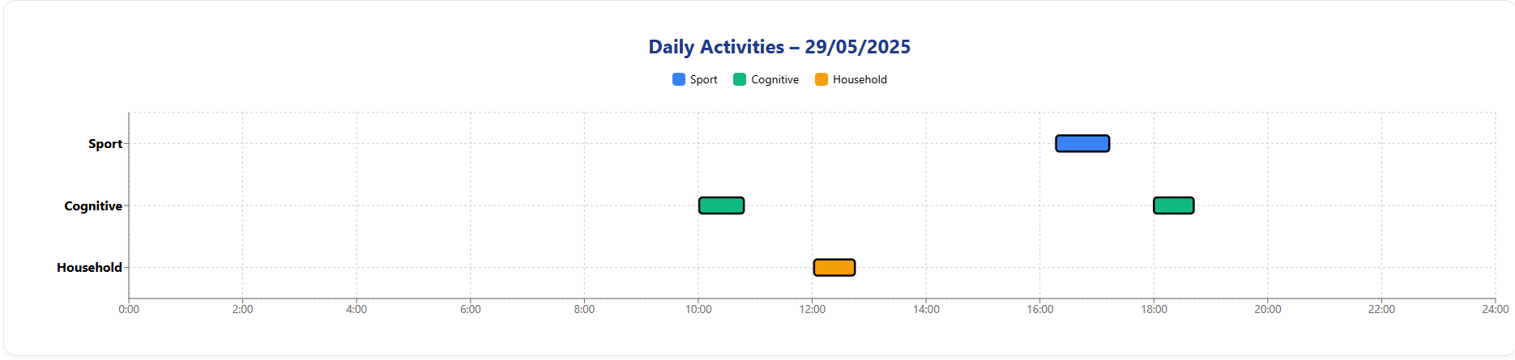**Daily Activities Graph:**

**Screenshot of the user hovering over an activity bar, displaying a tooltip with details such as name, start time, duration, and intensity:**

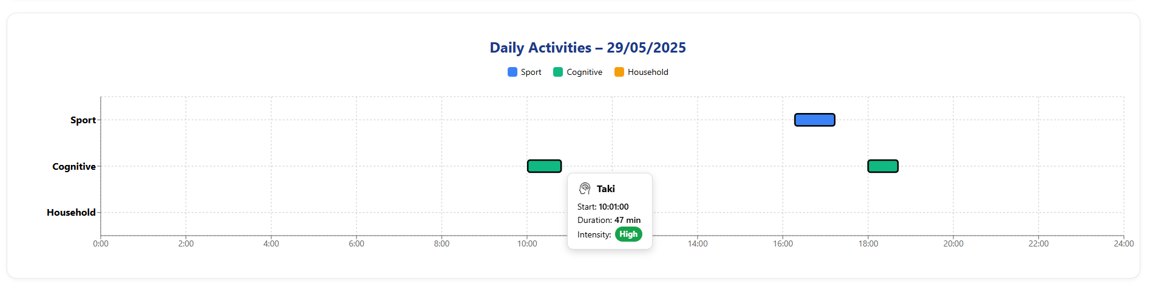

Please indicate what the advantages and/or disadvantages of **Daily Activities Graph** (**Gantt Chart**) visualization are in your opinion?

|  |  |  |  |  |  |  |  |
| --- | --- | --- | --- | --- | --- | --- | --- |
| Strongly agree |  |  |  |  |  | Strongly disagree |  |
| 7 | 6 | 5 | 4 | 3 | 2 | 1 |  |
|  |  |  |  |  |  |  | I thought the visualization was enjoyable |
|  |  |  |  |  |  |  | I found the visualization unnecessarily complex |
|  |  |  |  |  |  |  | I thought the visualization was easy to use |
|  |  |  |  |  |  |  | The use of visualization required considerable mental effort |
|  |  |  |  |  |  |  | The use of visualization was clear and understandable |
|  |  |  |  |  |  |  | The use of visualization was often frustrating |
|  |  |  |  |  |  |  | I thought the visualization was effective |
|  |  |  |  |  |  |  | I would imagine that most people would easily learn how to use this visualization. |

Please indicate what the advantages and/or disadvantages of **Daily Activities Graph** (**Gantt Chart**) visualization are in your opinion?

Advantages: ____________________________________________________________________________________________________________________________________________________

Disadvantages: ____________________________________________________________________________________________________________________________________________________

**System Usability Scale (SUS) Questionnaire:**

Please answer the following questions to evaluate the system:

|  |  |  |  |  |  |
| --- | --- | --- | --- | --- | --- |
| Strongly agree |  | Not sure |  | Strongly disagree |  |
| 5 | 4 | 3 | 2 | 1 |  |
|  |  |  |  |  | I think that I would like to use the system frequently |
|  |  |  |  |  | I found the system unnecessarily complex. |
|  |  |  |  |  | I thought the system was easy to use. |
|  |  |  |  |  | I think that I would need the support of a technical person to be able to use the system. |
|  |  |  |  |  | I found that the various functions in the system were well integrated. |
|  |  |  |  |  | I thought there was too much inconsistency in the system. |
|  |  |  |  |  | I would imagine that most people would learn to use the system very quickly. |
|  |  |  |  |  | I found the system very cumbersome to use. |
|  |  |  |  |  | I felt very confident using the system. |
|  |  |  |  |  | I needed to learn a lot of things before I could get going with the system. |